|  |
| --- |
| South Africa Livelihood Zone Profile  59203 – Southern Limpopo Open Access Cattle and Crops (*ZASLC*) |
| Zone Description |

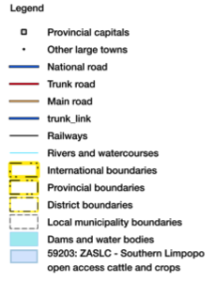This zone mostly is located on the hills and mountains of the highveld Olifants River basin, spilling over the escarpment to the edge of the eastern lowveld. It lies south-east of Polokwane and falls within Capricorn, Greater Sekhukhune and Mopani districts.

Figure 1: Map of the livelihood zone

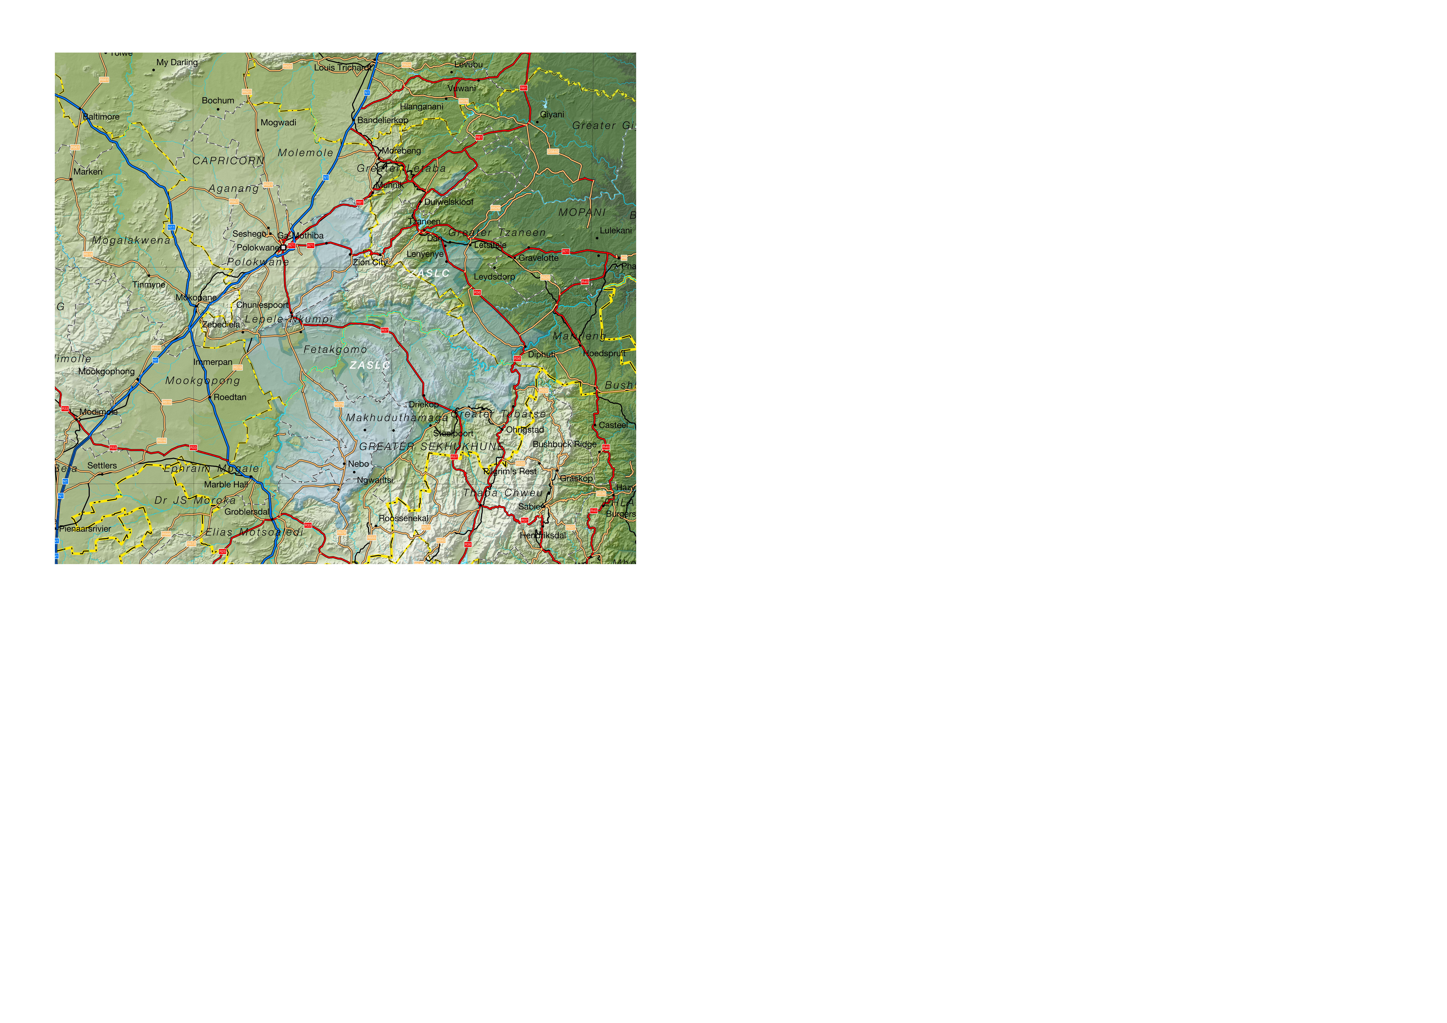Projection: Albers Equal Area with Standard Parallels at 22.67 S and 24.88 S, Longitude of Centre at 29.29 E.

Sources of data: Open Street Map, Highways (<http://wiki.openstreetmap.org/wiki/Planet.osm>) for the road lines, Shuttle Radar Topography Mission (SRTM) 3 version 2.1 (<http://www2.jpl.nasa.gov/srtm/>) for the elevation and relief shading and Agricultural Geo-referenced Information System (AGIS) (<http://www.agis.agric.za/agisweb/agis.html>) for place names, boundaries and rivers.

Most of the zone receives 400 to 600 mm mean annual rainfall, which allows for cultivation but can be unreliable. The escarpment, along the Mopani district border, receives good rainfall but it is too steep to farm. Soil quality influences water retention and moisture availability varies widely across the zone, with Fetakgomo, northern Makhuduthamaga and northern Greater Tubatse all considered “moderate to severe”, while south-west Lepele-Nkumpi is considered “severe”. On the other hand, the lowveld sections, north-east Lepele-Nkumpi, Polokwane, Elias Motsoaledi, Ephraim Mogale and southern Makhuduthamaga are have “moderate” to “slight” water availability; in particular, the land capability in southern Makhuduthamaga is classified “high potential arable”, due to its rainfall, soils and lack of slope.

Figure 2: Livelihood zone location



Table I - Census 2011 population breakdown of districts and municipalities covered by the livelihood zone

|  |  |  |  |  |
| --- | --- | --- | --- | --- |
| **Province** | **District** | **Municipality** | **Pop. Est. in ZASLC** | **Percent of total** |
| Limpopo | Capricorn | Lepele-Nkumpi | 189,831 | 82.42% |
| Polokwane | 221,049 | 35.15% |
| Greater Sekhukhune | Elias Motsoaledi | 103,896 | 41.66% |
| Ephraim Mogale | 45,864 | 37.10% |
| Fetakgomo | 86,571 | 92.37% |
| Greater Tubatse | 293,058 | 87.31% |
| Makhuduthamaga | 269,355 | 98.20% |
| Mopani | Greater Letaba | 39,846 | 18.74% |
| Greater Tzaneen | 178,560 | 45.78% |
| Maruleng | 81,657 | 86.10% |
| **Provincial Total** |  |  | **1,509,687** | **27.95%** |

Source: Statistics South Africa, Census 2011 small area population data

Huge investments in mining, especially around Burgersfort and Steelpoort, have boosted some work opportunities, but the majority of the rural population see few gains.

**Figure 1** is a map of the zone and **Figure 2** shows its location. The R37, R71, R518 and R579 are important trunk routes through the zone, while the R36, R81 and R555 skirt the periphery on the east, north and south, respectively. Polokwane serves as the main administrative and business centre to people in the zone. There are two railways, to Steelpoort and to Tzaneen, but rail services have little impact on the day-to-day lives of people in the zone.

The livelihood zone has been given an alphabetic code (or abbreviation) of 'ZASLC' and a numeric code of 59203. These codes distinguish the zone both nationally and internationally, as well as allowing zone name changes and updates if desired (the code should always remain the same).

Figure 3: Gender and age breakdown of the zone population (Statistics SA, Census 2011 data)

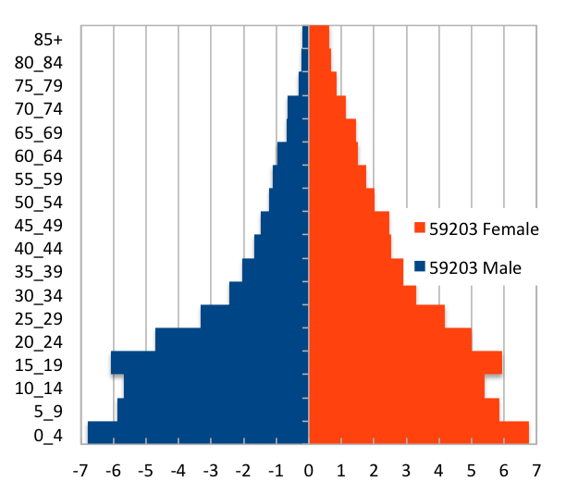 Source: Statistics South Africa, Census 2011 small areas and population database

As **Figure 1** shows, the livelihood zone spans ten municipalities in three districts. There are also areas in each municipality (some quite small, for example, in Makhuduthamaga) that are *not* part of the zone, however. The total population in the zone is 1,509,687 (from the Census 2011) and this is 27,95% of the provincial total. The breakdown for each municipality is given in **Table I**.

The age and gender pyramid is given in **Figure 3**. It is important to note the low proportions of adult men in the livelihood zone as well as the high proportion of children (younger than 20). This unbalanced gender and dependency ratio is a consequence of apartheid, as most of the zone was a part of the former *bantustans*, supplying labour to urban, industrial and mining areas. The persistence of this pattern leads to shortages in the zone of human capital, which has impacts on productivity.

|  |
| --- |
| Seasonal Calendar |

Figure 4: Seasonal calendar

|  |
| --- |
| Wealth Breakdown |

Wealth in this livelihood zone is determined primarily by three factors:

1. Employment, a product education and good social connections;
2. Ownership of a business, such as a spaza shop or bakkie, taxi; and
3. 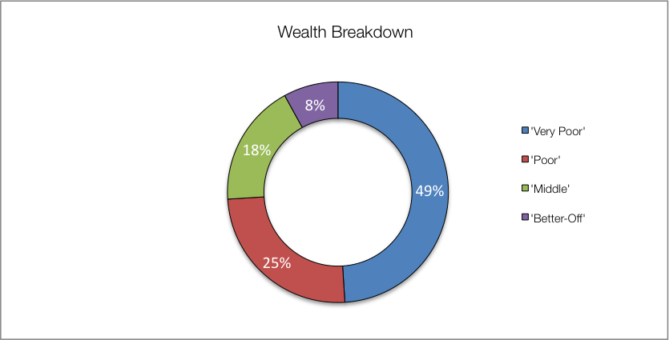Livestock, especially cattle.

Figure 5: Wealth breakdown in the southern Limpopo open access cattle and crops livelihood zone

|  |  |  |  |  |  |
| --- | --- | --- | --- | --- | --- |
| Category | Item | Wealth Group (typical value in brackets) | | | |
| 'Very poor' | 'Poor' | 'Middle' | 'Better off' |
| Hh Size |  | 4-10 (6) | 4-8 (6) | 5-8 (6) | 3-6 (5) |
| Land (Ha) | Owned | 0-2 (1) | 0-2 (1) | 0-2 (1) | 0-2 (1) |
| Cultivated | 0-2 (½) | 0-2 (1) | 0-2 (1) | 0-2 (1) |
| Livestock (head) | Cattle | 0 | 0-6 (3) | 0-15 (10) | 5-30 (18) |
| Goats | 0-2 (1) | 0-6 (3) | 0-20 (8) | 0-25 (15) |
| Income | Main | Grants | Grants | Formal employ | Formal employ |
| Annual (R) | 33,700 | 44,600 | 88,500 | 300,200 |

Source: Survey output, 2015

The wealthiest households, described as the 'better-off', are those with permanent work and a salary of R10,000 to R30,000 a month. Other households, that have lower, or less permanent work, valued at R5,000 to R10,000 average per month, are referred to as the 'middle'. Those who depend more on grants and may seek additional casual work, are described as the 'poor' and 'very poor'; collectively, they are almost three-quarters of the local population.

Wealthier households may cultivate larger farms but differences are not significant. All households are allocated the same size stands, so land ownership is the same.

Key informants in the villages tended to estimate larger household sizes, so field teams recorded values in excess to those reported in other surveys, especially the census. Except for single-people, the most frequent household size in this zone is four, while the greatest number of people reside in a household of five. The reported typical household size of 5-6 people, which is used in ensuing sources of food and income—these can be scaled to the appropriate household size from the census.

|  |
| --- |
| Sources of Food |

Purchases are the largest source of people's food, contributing 85% to nearly 100% of minimum food energy needs. The contribution from staple food purchases *decrease* steadily as households get wealthier. Conversely, the contribution to food energy of non-staple food purchases *increases* with increasing wealth. Most households and all wealth groups also consume food from their own crop production. The contribution to household food energy from both staple and non-staple crops rises gradually with wealth, from about 20% to 45%.

Figure 6: Sources of food (expressed as percentage of minimum average food energy needs) for each wealth group

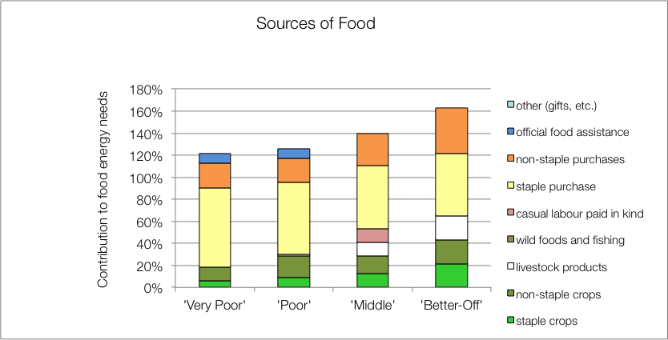

Only the 'middle' and 'better off' households obtain food from their livestock; this is usually from cow's milk and occasional slaughter for meat. Dairy production in this zone is not commensurate with herd sizes and livestock ownership. In general, a fraction of lactating cows (about 1:4 to 1:10) are actually milked for consumption.

The poorest households' children receive additional food from school lunches, which is their official food assistance. Wealthier households tend to send their children to fee-paying schools that do not offer any kind of meals.

|  |
| --- |
| Sources of Cash Income |

Cash incomes vary considerably across wealth groups, with the 'better off' earning almost nine times (R300,200 per annum) as much as the 'very poor' (R33,700 per annum). **Figure 7** shows this distribution—it must be noted that the bars in the figure are not quartiles, they represent wealth groups and wealth groups are *not* distributed evenly (see **Wealth Breakdown**, above).

The main sources of cash incomes in the zone are: formal employment—for the 'middle' and 'better off'—and cash grants—for the 'poor' and 'very poor'. This is in keeping with most surveys ask for the main livelihood source.

Figure 7: Sources of annual cash income by wealth group

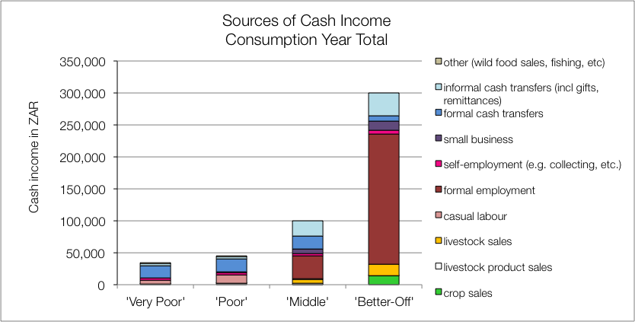

However, the point of this enquiry was to gain understanding of how *all* livelihood sources come together to make up an income. This is important because it enables practitioners to link a hazard (such as a price change) to an income and it enables other users to see potential areas of intervention. By dividing the value of each source by the total income, we can see these proportions and this is presented in the graph in **Figure 8**.

Figure 8: Sources of annual cash income as a percentage of total, by wealth group

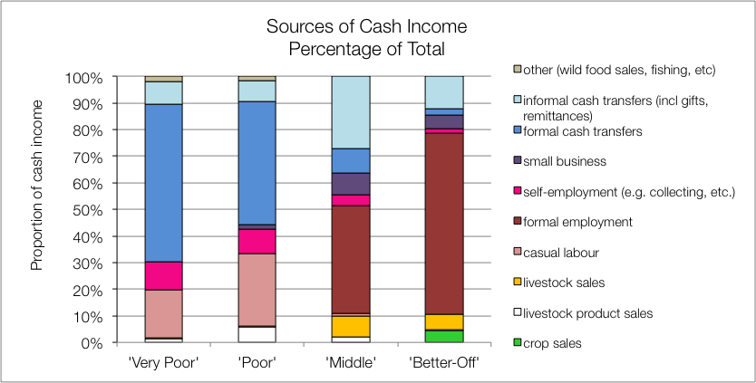

For the 'very poor' and 'poor', grants make up 59% and 46% of total cash income, respectively; the remainder coming from casual labour (mostly domestic work, agricultural piece work, construction jobs), self-employment (collecting natural products for sale, weaving, making bricks, etc.) and informal cash transfers (usually remittances). Tiny amounts of income are earned through sale of wild foods and sale of animal products (usually meat or eggs).

The 'middle' and 'better off', by contrast, depend on a formal wage or salary for the better part of their income. This may or may not be permanent, for example, many 'middle' households have a member that works seasonally on the commercial farms. Cumulatively, this amounts to R36,000 per annum for 'middle' households but it may be earned only during key labour-demand months, when the actual payments are higher than the average of R3,000 per month that this annual amount implies. 'Middle' and 'better off' households also earn cash through livestock sales, small business and also through some grants (for example, pensions and fostering are not means-tested and the probability of a household having a pensioner in it is about one in two—see the population pyramid under **Zone Description**).

The numbers of cows that are actually milked compared with those likely to be lactating, is low. This is due to a number of factors: lack of economic incentives, lack of time by the cattle-owners (because they are full-time employed) and minimal herd management.

|  |
| --- |
| Hazards, Vulnerabilities and Response Strategies |

Since households are dependent on markets for most of their food, households are therefore most vulnerable to market shocks. These 'market shocks' may consist of: escalating food prices, eroded grants (for example, when they are not adjusted to match consumer inflation) and job losses.

Drought can also have an impact, as it will reduce crop production and remove this source of food. However, unless food prices also rise simultaneously, households will manage crop losses by prioritising more cash to food purchases.

Additional response strategies households may engage in under stress are: switching expenditure, seeking more casual work (usually outside of the village) or selling off assets or belongings.

|  |
| --- |
| Household Hunger Scores |

The majority of the households (75 percent) experience no to little hunger and only one household (nil percentage points) reported severe hunger in this livelihood zone. Only 22 percent of the households reported a moderate hunger situation (see **Table II**).

Table II - Household Hunger scale indicator

|  |  |  |  |  |  |
| --- | --- | --- | --- | --- | --- |
| No to Little Hunger | | Moderate Hunger | | Severe Hunger | |
| Count | Percent | Count | Percent | Count | Percent |
| 229 | 75 | 76 | 25 | 1 | 0 |

Source: Survey Output 2015

|  |
| --- |
| Dietary Diversity and Food Consumption Scores |

Figure 10: Food consumption scores

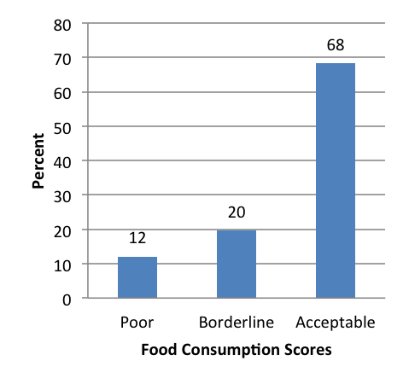

Figure 9: Dietary Diversity Scores

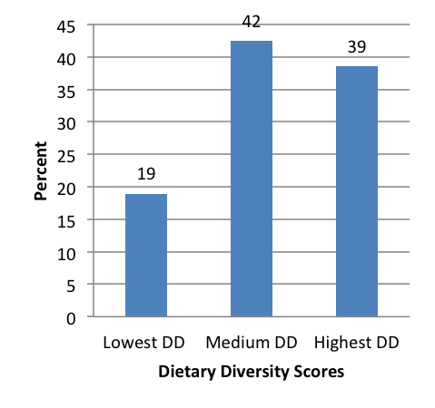

The largest number – 42 percent of sampled households – have a medium dietary diversity score indicating that they consumed about four to five food groups during the day before the survey. 39 Percent of households have highest dietary diversity (consume at least six food groups), there is a high percentage of households with the lowest dietary diversity (19 percent), indicating that they consume three or fewer food groups.

On food consumption scores, the majority of households (68 percent) were consuming adequately diversified diets. 20 Percent of the households were within borderline consumption and about 12 percent of households consume an unacceptable diversity of foods.

|  |
| --- |
| Nutrition and Anthropometry |

About five percent and three percent of under-five children were moderately and severely malnourished, respectively in the livelihood zone (Figure 11). Moderate acute malnutrition is predominant in the 0-5 months under-five children. The results indicate that there were no severe or moderately malnourished children within twelve to thirty five months old children in the livelihood zone.

Figure 11: Prevalence of severe and moderate acute malnutrition by age grouping

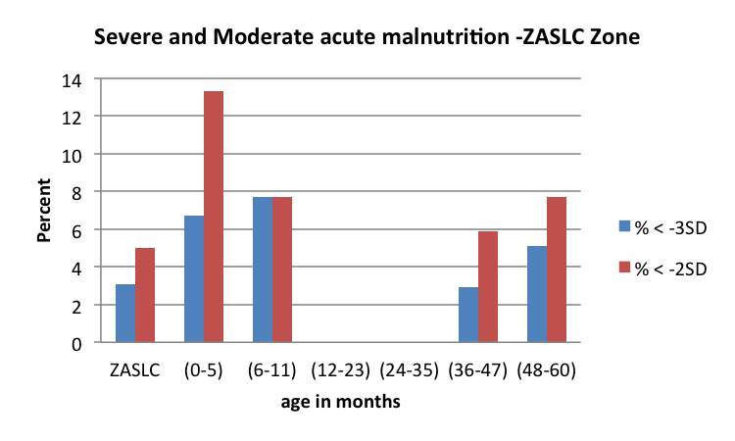

Figure 12: Prevalence of severe and moderate stunting by age grouping

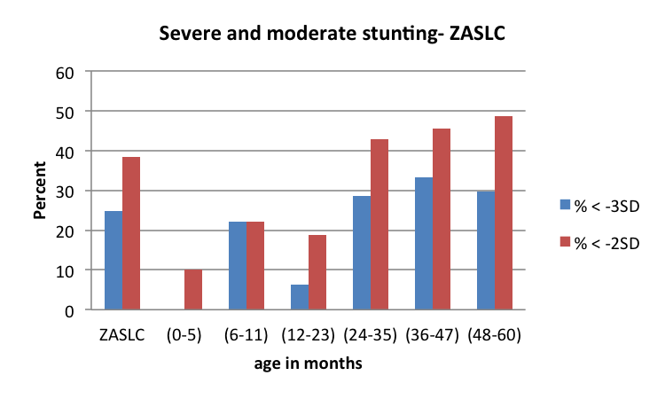

The prevalence of severe and moderate stunting is 25 percent and 38 percent, respectively in the livelihood zone (Figure 12). There is a high prevalence of severe (30 percent) and moderate stunting (49 percent) among under-five children within 48 to 60 months of age. The trend of severe and moderate stunted under-five children is almost the same between the age group categories of 24 months to 47 months old. The results also indicate that there are no severely stunted children between zero months and 35 months old among under-five children in the livelihood zone.

Figure 13: Prevalence of severe and moderate underweight by age grouping

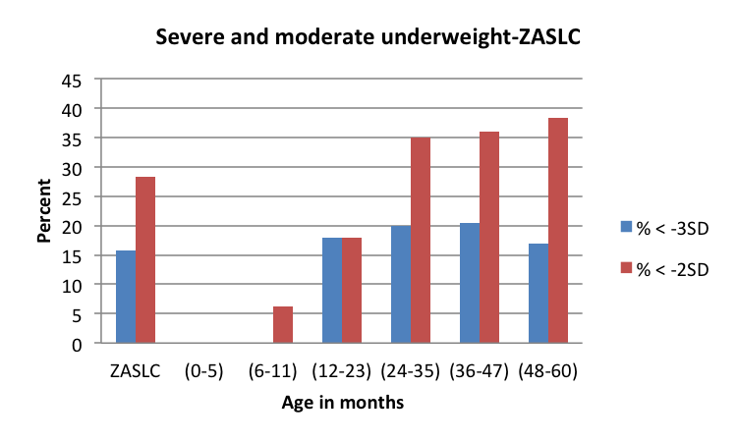

The prevalence of moderate and severe underweight were 28 percent and 16 percent, respectively in the livelihood zone (Figure 13). There is a high prevalence of moderate underweight (38 percent) among under-five children within 48 to 60 months of age seconded by children who are within age categories of 36 to 47 months old. The results indicate that there is a zero prevalence of severe and moderate underweight within age category of zero months to five months of age in the livelihood zone.

|  |
| --- |
| Conclusions and Recommendations |

As already mentioned, food and cash income from livestock products is low for the numbers of animals present. To increase production, herds would need more and better management, an investment that would need to be justified through better returns. These returns could be increased by, for example, support to dairy marketing and greater provision of services and infrastructure to encourage production. Crop farming yields could also be improved through greater service provision and market support, though crops are constrained by environmental factors. This increased productivity will unlikely benefit all but a few households directly, but will create additional new possibilities through increased work opportunities. For many 'poor' and 'very poor' households, grants will remain the main source of income for some time to come.